# Deploying VITE application to github.

Step1: npm run build (it will build a production application)

Step2: Then visit the site :

<https://vitejs.dev/guide/static-deploy.html>

You can try and check the steps given in the site.

Step3: Edit the vite.config.js file

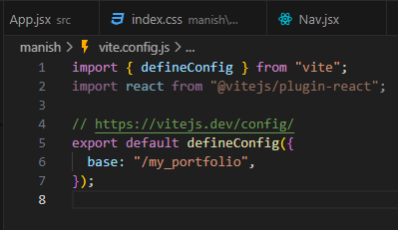

Step4: Make a github repository and upload all the files to the repository.

Step5: Copy the yml code from the above site.

Step6: Got to settings > pages > github actions > create your own

Paste the yml code here and

name the file to deploy.yml

commit changes

and go to actions

then you will see the below button and click on it



Step7: You will get the link to the website here or

You can go to settings again and pages.

There you will get the link of the hosted website.

# Conditionally rendering list items

We use ternary operator for achieving this as:

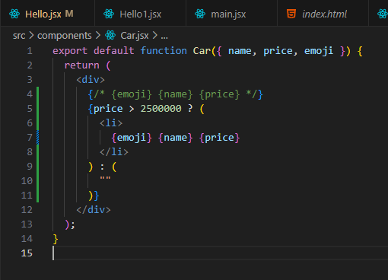

# Event handling in React

Same as in JS, we use the event handling in React.

